Name | Description | Picture
Beaker | Used to hold and heat liquids. Multipurpose and essential in the lab. NOT USED TO MEASURE LIQUID | 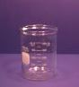
Bunsen Burner | Bunsen burners are used for heating and exposing items to flame. They have many more uses than a hot plate, but do not replace a hot plate. | 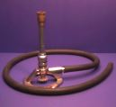
Crucible | Crucibles are used to heat small quantities to very high temperatures. | 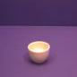
Erlenmeyer Flask | The Erlenmeyer Flask is used to heat and store liquids. The advantage to the Erlenmeyer Flask is that the bottom is wider than the top so it will heat quicker because of the greater surface area exposed to the heat. | 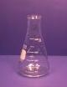
Evaporating Dish | The Evaporating Dish is used to heat and evaporate liquids. | 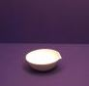
Funnel | The Funnel is a piece of equipment that is used in the lab but is not confined to the lab. The funnel can be used to target liquids into any container so they will not be lost or spilled. | 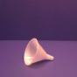
Goggles | Goggles are worn at ALL times during labs. Goggles are made of special material and have a design that protect your eyes from every angle. | 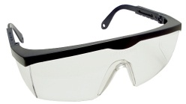
Graduated cylinders | Graduated cylinders should be used when measuring liquid. They are very accurate when measuring. | 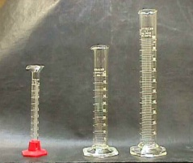
Mortar and Pestle | The Mortar and Pestle are used to crush solids into powders for experiments, usually to better dissolve the solids. | 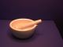
Ring | Rings are used in conjunction with wire gauze to heat beakers. | 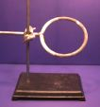
Ring Stand | Ring stands are used to hold items being heated. Clamps or rings can be used so that items may be placed above the lab table for heating by bunsen burners or other items. | 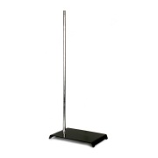
Scoopula/  scoop | Used to scoop chemicals into other containers. You should never touch chemicals with your hands. | 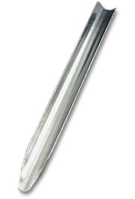
Stir Rod | The stir rods are used to stir things. They are usually made of glass. Stir Rods are very useful in the lab setting. | 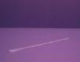
Scale | Scales are used for determining the mass of objects (units will be giving in grams) | 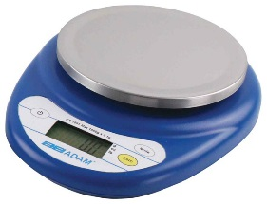
Striker | Uses flint and steel to create sparks, which ignite the Bunsen burner. | 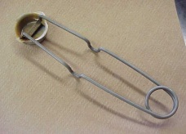
Test tube Brush | The test tube brush is used to easily clean the inside of a test tube. | 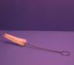
Test tube Holder | The holder is used to hold test tubes when they are hot and untouchable. | 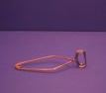
Test tube Rack | The testtube rack is used to hold testtubes while reactions happen in them or while they are not needed. | 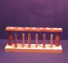
Crucible Tongs | Tongs are used to hold many different things such as flasks, crucibles, and evaporating dishes when they are hot. NOT BEAKERS. | 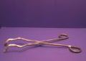
Beaker Tongs | Tongs are used to hold beakers only. | 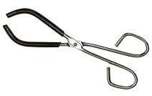
Triangle | The triangle is used to hold crucibles when they are being heated. They usually sit on a ring stand | 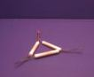
Weigh Boat | An open container, often disposable, used for weighing samples. | 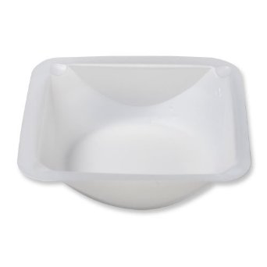
Watch Glass | The watch glass is used to hold solids when being weighed or transported. They should never be heated. | 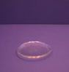
Wire Gauze | Used in conjunction with the ring to heat up a beaker evenly. | 